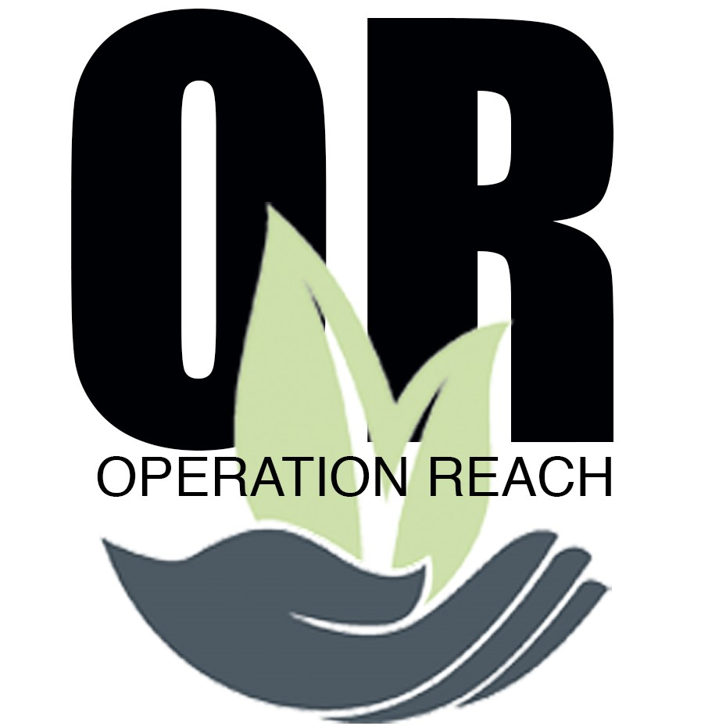

Phone Contact: (941) 417-2294
Mailing Address: P.O. Box 788 Palmetto, FL. 34220
Website: www.lifechangersinternational.org
Email: life_changers@hotmail.com
Tax ID# 26-2923694

Operation Reach History

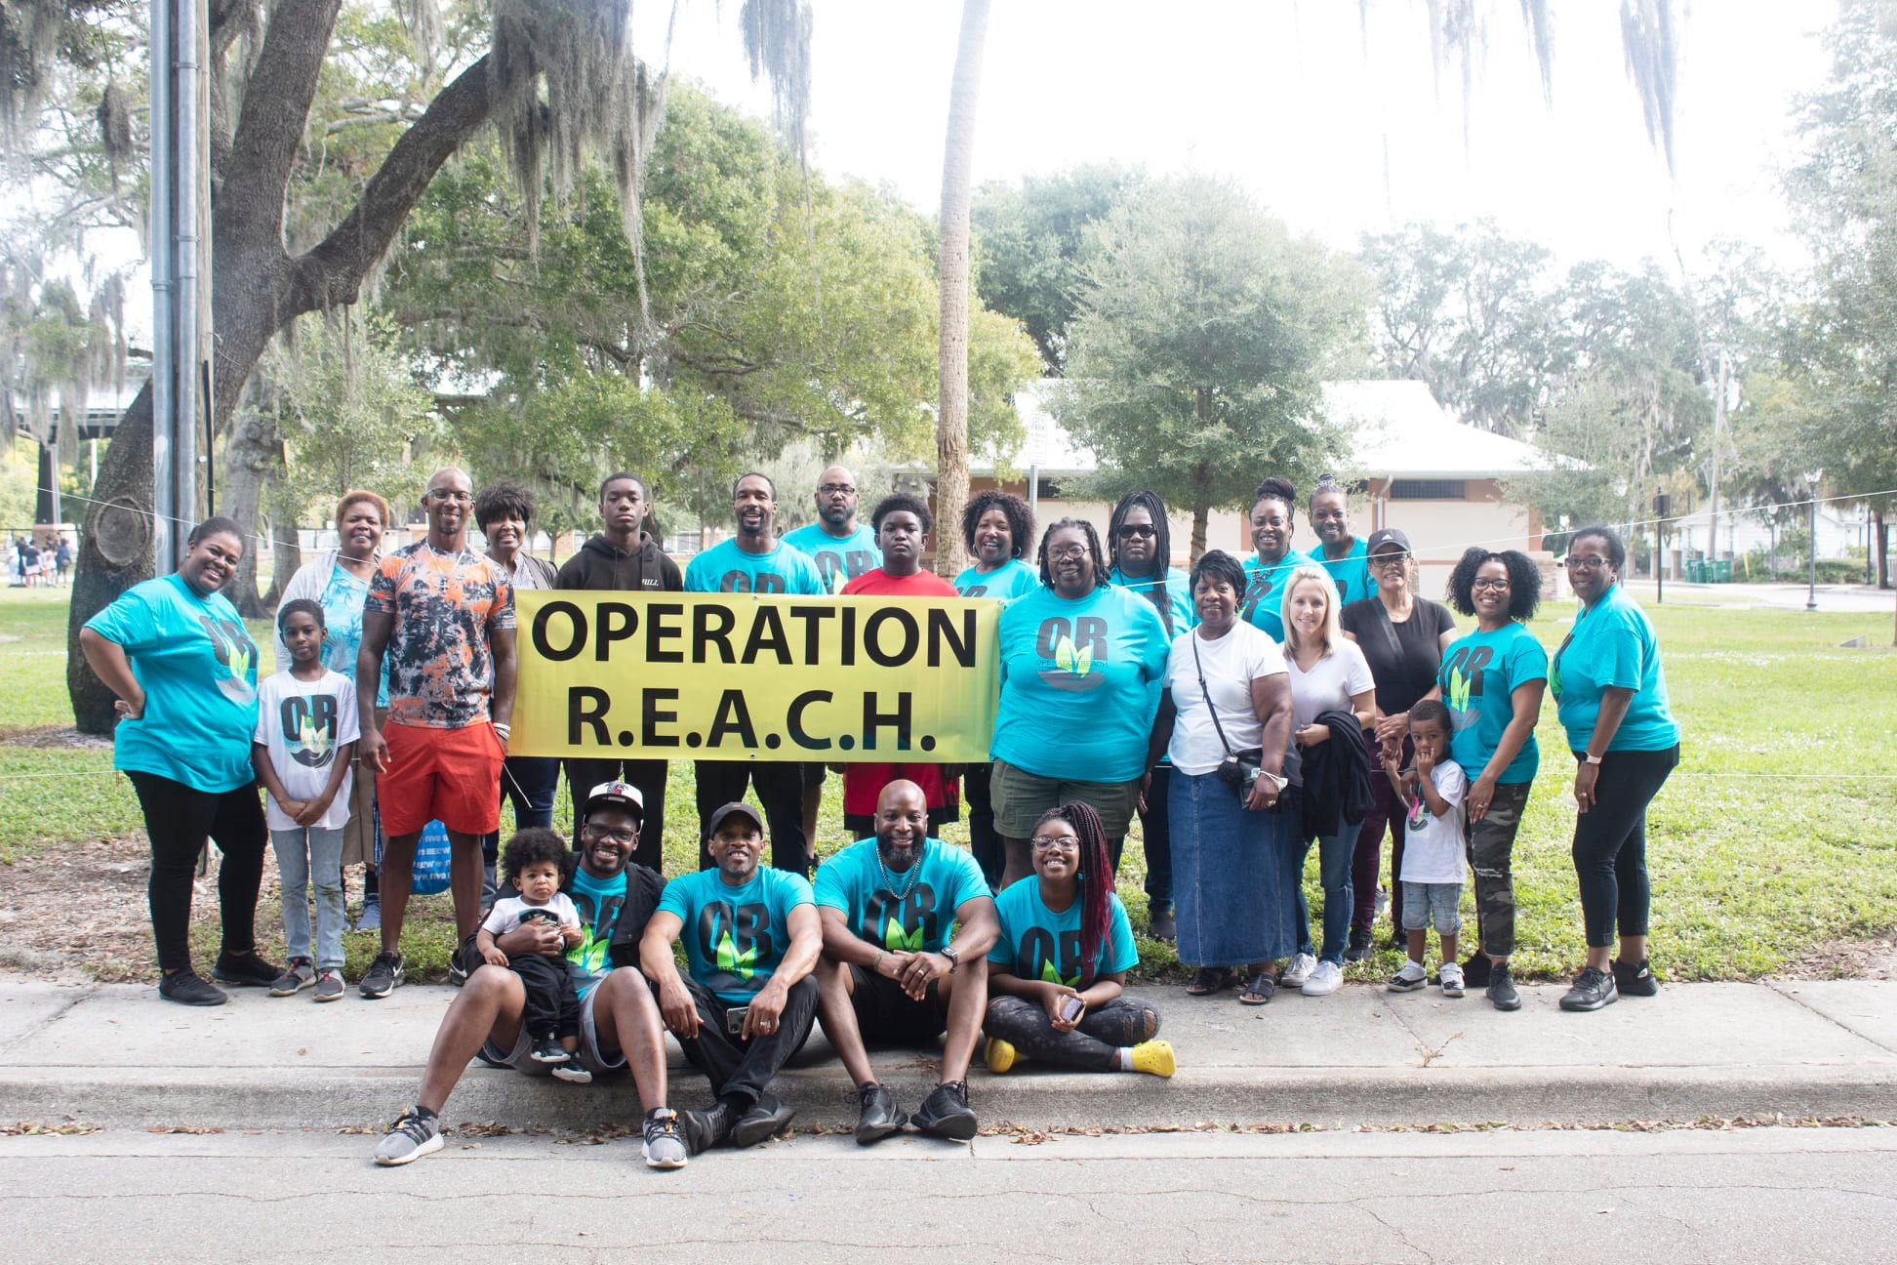
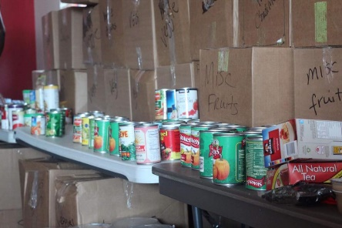
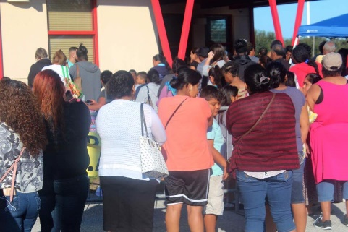
Under the leadership of Pastor Kevin Washington, Operation Reach was established in the year of 2012 as an expansion of Life Changers International World Ministries. The beginning stages of our community outreach services started in 2009 with our food pantry, serving families year-round. As we identified the greater needs in our community during the holidays of Thanksgiving and Christmas, we wanted to add additional services that would reach further into our community and into the homes of those who are in dire need. Operation Reach’s purpose is to serve our community at large during the holiday seasons of Thanksgiving and Christmas. In doing so, our food pantry ministry expanded its resources to the Sarasota Mayors Feed the Hungry, Palmetto Boys and Girls Club, Feeding Tampa Bay, Meals on Wheels food bank of Manatee County, the Compassionate Center and many more. Our partnership with these organizations has enabled us to grow, impact and serve over 300 families within our community each year since 2012. We are continually excited and with great expectations that our services will continue to change lives that will impact the world.

Operation Reach Q&A
- What is our mission?
  - To Serve Our Community
- What are our goals?
  - To help provide a meal/perishable items
  - To bring hope and compassion to families in destress during the holidays.
  - To be a leading resource that brings awareness and support for families in need throughout our community.
- What items do we give to our families in need?
  - Perishable food items / gift baskets
  - Free $10 Publix gift cards (limited up to 4 per household)
  - Turkeys (1 Turkey per household) Not advertised per distributors (first come first serve basis)

- Who do we serve?
  - We are currently serving Manatee and Sarasota counties.
- Where do we get our donations from?
  - Mayors Feed the Hungry Food Drive
  - Local persons
  - Business & corporate sponsors
- Do we accept monetary donations?
  - Yes, Life Changers International World Ministries Operation Reach Program is for non-profit. Your donations are tax deductible and will be used to impact lives of those in need. You can donate via our website at
www.lifechangersinternational.org or through the Givelify App.
- What is the process for a family that is in need?
  - Each year Operation Reach in partnership with the Mayors Feed the Hungry has a registration period for families to register for gift cards. Each household are to provide a copy of social security cards and a valid ID. During this period dates and times are set for distribution of food and gift cards in which families can come and receive. When registrants come the day of Operation Reach, they are to provide Matching ID to submitted applications on file to obtain all free items provided. As our desire is to serve all, we will continually work diligently making sure distribution is fairly distributed to all.

- Do we need volunteers?
  - Yes, yes and yes. We are always looking for those who have a heart to serve.
  - Volunteer workers may be asked to lift heavy boxes and food sorting
  - Volunteer workers may be asked to help carry food bags to cars for the elderly.
  - Bilingual/ Spanish speaking are greatly needed
  - Set up and take down workers are needed

- Where is the Operation Reach Event Held?
  - Palmetto Boys & Girls Club 1600 10th St. West 34221
  - Every November, the Saturday before Thanksgiving from 8am-1pm
- What to expect at this event?
  - An atmosphere filled with compassion and love for the community.
  - Prayer with all families prior to start of distribution. (Prayer Table)
  - Inspirational Music
  - Other community agencies and resources onsite for those in need
  - Free food (perishable items) for the community while supplies last
  - Gift cards for all pre-registered families
  - Activities for kids
  - Turkeys (providing availability and while supplies last)
- What are our future expectations?
  - To open a year-round facility with enough space to hold our Operation Reach distribution and as well as housing our monthly food pantry.
  - To add addition items that will help families such as
    - Clothing
    - Hygiene Products
    - Blankets for the winter
    - Hot meals for delivery to home bound persons
    - Emergency aid to families in need of food and shelter
- Who do I contact for Operation Reach?
  - Outreach Director: Carol Johnson

- Are we on the web and social media? Yes
  - www.lifechangersinternation.org
  - Facebook, Instagram

Our Community Partners
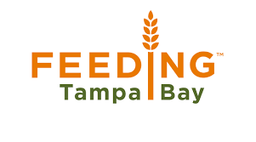

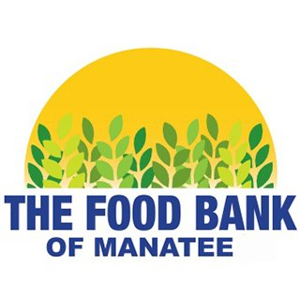
Azinger Family
Compassion Center

